
REGIONAL BUSINESS FORUM
REGIONAL BUSINESS FORUM
October 1-4, 2019, Novi Sad

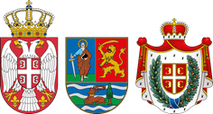
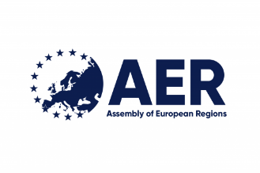

Assembly of European Region and the Autonomous Province of Vojvodina in cooperation with the Chamber of Commerce and Industry of Vojvodina, Vojvodina Development Agency, Novi Sad Fair and Enterprise Europe Network - Serbia are organizing the Second Regional Business Forum on October 1st and 4th, 2019.

Forum participants will be established companies, as well as regional chambers of commerce, regional development agencies and/or other institutions supporting SMEs development and enhancing investment climate.

Regional Business Forum will give the companies the opportunity to express and present their business potentials, ideas, and connect with other companies and institutions supporting SME development and new investments. This year’s Regional Business Forum will coincide with the 52nd International Fair of Hunting, Fishing and Tourism in Novi Sad.

International event provides additional support to the companies to find international partners at the Forum. The participants are offered to choose their potential partners according to their own needs and information about partner’s business and interests.

The sectors that will be represented are:

- Agriculture and Food Industry
- Metal Processing Industry
- Automotive Industry Parts
- ICT
- Tourism

The B2B platform is available at http://rbf2019novisad.talkb2b.net/, providing the possibility to promote business cooperation between regions, including agreements on free trade and production, joint ventures and joint access to third markets, as well as the exchange of technologies and know-how and cooperation in projects characterized by a high degree of competitiveness and innovation, funded by the EU and other donors.

For additional information please visit rbf.vojvodina.gov.rs or contact: rbf2019@vojvodine.gov.rs

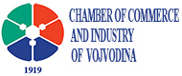 | 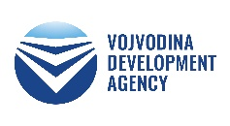 | 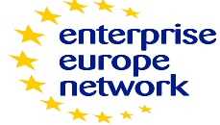 | 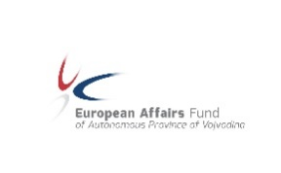 | 