REGIONAL BUSINESS FORUM II
Chamber of Commerce and Industry of Vojvodina,
11 Hajduk Veljkova St, Novi Sad,
October 1- 4, 2019.

PROGRAMME

Tuesday, October 1st, 2019

9.30 – 10.00 Registration
9.45 – Press statements
10.00 – 11.00 Official opening and Plenary session
11.30 – 13.00 B2B meetings, sectors:

- Agriculture and Food Industry,
- Metal Processing Industry,
- Automotive Industry Parts,
- ICT

13.00 – 14.00 Lunch, exhibition area
14.00 – 16.00 B2B meetings

Wednesday, October 2nd, 2019

10.00 – 13.30 Study visits - NS Seme - Institute of Field and Vegetable Crops
- IT company Levi9
14.00 – 15.00 Lunch

Free afternoon, sightseeing

Thursday, October 3rd, 2019 (Novi Sad Fair – “Master” Hall)

11.30 – 16.00 B2B meetings – Tourism

Friday, October 4th, 2019 (Novi Sad Fair – “Master” Hall)

11. 30 - 16. 00 B2B meetings – Tourism

Partners:
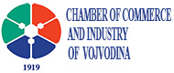 | 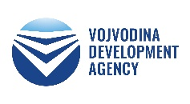 |  | 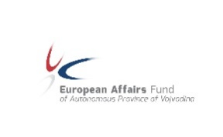 | 